Assignment 9.1

Problem Statement

1. Use the below given data set

Data Set

2. Perform the below given activities:

a. Create classification model using logistic regression model

b. verify model goodness of fit

c. Report the accuracy measures

d. Report the variable importance

e. Report the unimportant variables

f. Interpret the results

g. Visualize the results

library(C50)

data(churn)

head(churnTrain)

head(churnTest)

#churnTrain = churnTrain[1:500,]

#churnTest = churnTest[1:500,]

# logistic regression model:

fit <- glm(churn~.,data = churnTrain,family = binomial(link='logit'))

summary(fit)

> # logistic regression model:

> fit <- glm(churn~.,data = churnTrain,family = binomial(link='logit'))

> summary(fit)

Call:

glm(formula = churn ~ ., family = binomial(link = "logit"), data = churnTrain)

Deviance Residuals:

Min 1Q Median 3Q Max

-3.0431 0.1661 0.3123 0.4995 1.9487

Coefficients:

Estimate Std. Error z value Pr(>|z|)

(Intercept) 9.686e+00 9.798e-01 9.885 < 2e-16 ***

stateAL -3.385e-01 7.629e-01 -0.444 0.657272

stateAR -9.106e-01 7.519e-01 -1.211 0.225884

stateAZ -8.973e-02 8.452e-01 -0.106 0.915453

stateCA -1.816e+00 7.822e-01 -2.322 0.020238 *

stateCO -6.445e-01 7.631e-01 -0.845 0.398339

stateCT -1.021e+00 7.252e-01 -1.408 0.159167

stateDC -6.880e-01 8.081e-01 -0.851 0.394577

stateDE -7.460e-01 7.490e-01 -0.996 0.319234

stateFL -5.916e-01 7.610e-01 -0.777 0.436956

stateGA -6.601e-01 7.778e-01 -0.849 0.396075

stateHI 2.300e-01 8.963e-01 0.257 0.797469

stateIA -2.083e-01 9.024e-01 -0.231 0.817410

stateID -8.705e-01 7.474e-01 -1.165 0.244100

stateIL 2.382e-01 8.340e-01 0.286 0.775165

stateIN -4.410e-01 7.526e-01 -0.586 0.557924

stateKS -1.062e+00 7.296e-01 -1.455 0.145659

stateKY -7.889e-01 7.658e-01 -1.030 0.302931

stateLA -5.546e-01 8.352e-01 -0.664 0.506716

stateMA -1.161e+00 7.430e-01 -1.562 0.118261

stateMD -1.144e+00 7.168e-01 -1.596 0.110430

stateME -1.327e+00 7.281e-01 -1.823 0.068321 .

stateMI -1.390e+00 7.137e-01 -1.948 0.051400 .

stateMN -1.160e+00 7.149e-01 -1.622 0.104709

stateMO -5.979e-01 7.741e-01 -0.772 0.439914

stateMS -1.355e+00 7.278e-01 -1.862 0.062601 .

stateMT -1.865e+00 7.166e-01 -2.603 0.009245 **

stateNC -5.765e-01 7.545e-01 -0.764 0.444822

stateND -1.274e-01 7.969e-01 -0.160 0.872995

stateNE -2.952e-01 8.055e-01 -0.367 0.713984

stateNH -1.160e+00 7.689e-01 -1.509 0.131367

stateNJ -1.572e+00 7.098e-01 -2.215 0.026757 *

stateNM -4.590e-01 7.867e-01 -0.583 0.559596

stateNV -1.251e+00 7.245e-01 -1.727 0.084198 .

stateNY -1.161e+00 7.191e-01 -1.614 0.106496

stateOH -6.726e-01 7.464e-01 -0.901 0.367508

stateOK -8.660e-01 7.557e-01 -1.146 0.251811

stateOR -7.684e-01 7.354e-01 -1.045 0.296126

statePA -1.141e+00 7.791e-01 -1.464 0.143121

stateRI 1.099e-01 8.198e-01 0.134 0.893337

stateSC -1.747e+00 7.371e-01 -2.370 0.017782 *

stateSD -8.227e-01 7.607e-01 -1.081 0.279510

stateTN -2.604e-01 8.207e-01 -0.317 0.751071

stateTX -1.637e+00 7.079e-01 -2.313 0.020745 *

stateUT -1.047e+00 7.435e-01 -1.408 0.159056

stateVA 4.425e-01 8.220e-01 0.538 0.590344

stateVT -8.390e-02 7.799e-01 -0.108 0.914330

stateWA -1.400e+00 7.237e-01 -1.934 0.053081 .

stateWI -2.836e-01 7.798e-01 -0.364 0.716109

stateWV -5.732e-01 7.329e-01 -0.782 0.434139

stateWY -2.952e-01 7.541e-01 -0.391 0.695449

account_length -9.646e-04 1.434e-03 -0.673 0.501212

area_codearea_code_415 7.876e-02 1.418e-01 0.555 0.578569

area_codearea_code_510 1.016e-01 1.632e-01 0.622 0.533622

international_planyes -2.192e+00 1.534e-01 -14.294 < 2e-16 ***

voice_mail_planyes 2.131e+00 5.944e-01 3.585 0.000337 ***

number_vmail_messages -3.832e-02 1.865e-02 -2.055 0.039866 *

total_day_minutes 3.823e-01 3.380e+00 0.113 0.909942

total_day_calls -4.045e-03 2.862e-03 -1.414 0.157477

total_day_charge -2.326e+00 1.988e+01 -0.117 0.906870

total_eve_minutes -8.927e-01 1.700e+00 -0.525 0.599510

total_eve_calls -1.018e-03 2.890e-03 -0.352 0.724642

total_eve_charge 1.041e+01 2.000e+01 0.521 0.602695

total_night_minutes 2.228e-01 9.044e-01 0.246 0.805401

total_night_calls -1.810e-04 2.928e-03 -0.062 0.950718

total_night_charge -5.039e+00 2.010e+01 -0.251 0.802042

total_intl_minutes 4.149e+00 5.494e+00 0.755 0.450194

total_intl_calls 9.055e-02 2.575e-02 3.516 0.000438 ***

total_intl_charge -1.567e+01 2.035e+01 -0.770 0.441115

number_customer_service_calls -5.366e-01 4.100e-02 -13.089 < 2e-16 ***

---

Signif. codes: 0 ‘***’ 0.001 ‘**’ 0.01 ‘*’ 0.05 ‘.’ 0.1 ‘ ’ 1

(Dispersion parameter for binomial family taken to be 1)

Null deviance: 2758.3 on 3332 degrees of freedom

Residual deviance: 2070.8 on 3263 degrees of freedom

AIC: 2210.8

Number of Fisher Scoring iterations: 6

> hoslem.test(churnTrain$churn, fitted(fit))

Hosmer and Lemeshow goodness of fit (GOF) test

data: churnTrain$churn, fitted(fit)

X-squared = 3333, df = 8, p-value < 2.2e-16

Warning message:

In Ops.factor(1, y) : ‘-’ not meaningful for factors

> #plot the fitted model

> plot(fit$fitted.values)

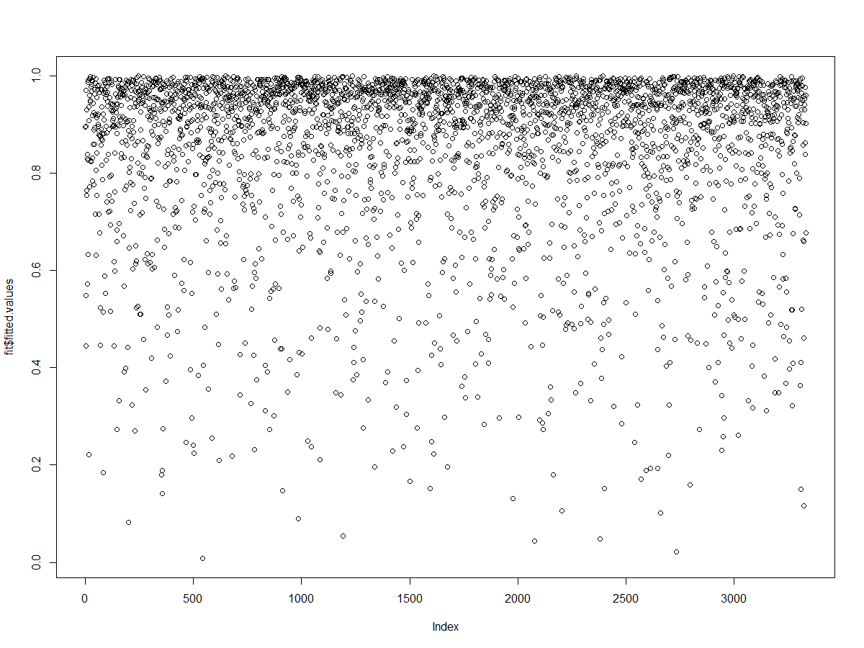

x <- 1:20

y <- 21:40

library(MASS)

boxcox(y~x)

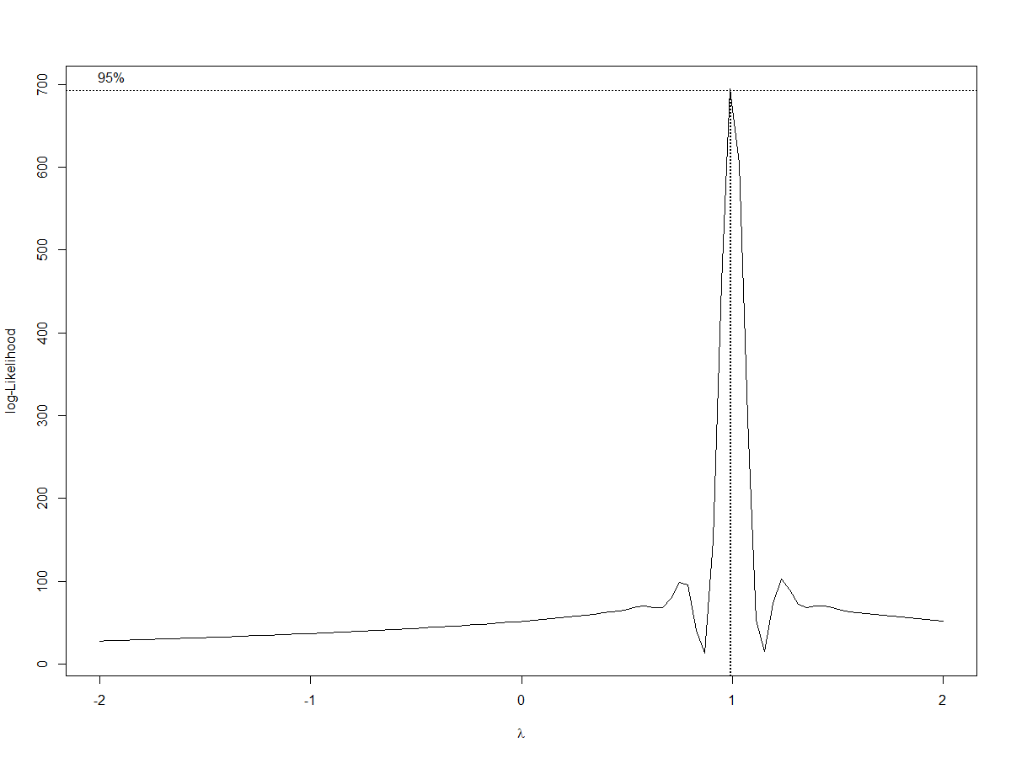

plot(1/y^2~x)

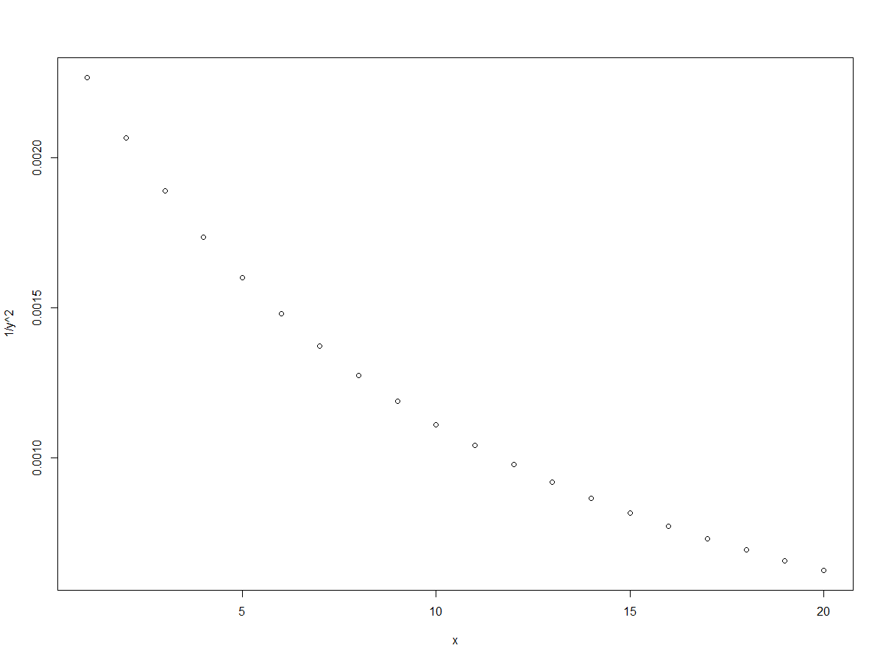

# load libraries

library(caret)

library(rpart)

# define training control

train_control<- trainControl(method="cv", number=10)

# train the model

model<- train(churn~., data=churnTrain, trControl=train_control, method="glm")

# make predictions

predictions<- predict(model,churnTest)

# append predictions

pred<- cbind(churnTest,predictions)

# summarize results

confusionMatrix<- confusionMatrix(pred$predictions,pred$churn)

confusionMatrix

> library(rpart)

> # define training control

> train_control<- trainControl(method="cv", number=10)

> # train the model

> model<- train(churn~., data=churnTrain, trControl=train_control, method="glm")

> # make predictions

> predictions<- predict(model,churnTest)

> # append predictions

> pred<- cbind(churnTest,predictions)

> # summarize results

> confusionMatrix<- confusionMatrix(pred$predictions,pred$churn)

> confusionMatrix

Confusion Matrix and Statistics

Reference

Prediction yes no

yes 54 48

no 170 1395

Accuracy : 0.8692

95% CI : (0.8521, 0.8851)

No Information Rate : 0.8656

P-Value [Acc > NIR] : 0.3492

Kappa : 0.2699

Mcnemar's Test P-Value : 2.503e-16

Sensitivity : 0.24107

Specificity : 0.96674

Pos Pred Value : 0.52941

Neg Pred Value : 0.89137

Prevalence : 0.13437

Detection Rate : 0.03239

Detection Prevalence : 0.06119

Balanced Accuracy : 0.60390

'Positive' Class : yes